Scavenger Hunt
With
Theodore the Turkey
Who Finds a Zoo
by Allison F. Speer (Allifish Press)
This is a great assessment for determining how well students remember and retain details while reading!

- Print 3-4 images EACH of the images below: Cowboy boots, a soccer ball, a zebra, a lion, a penguin, and a zookeeper.)

- Hide them in random places in your house or classroom.
- After reading "THEODORE, THE TURKEY WHO FOUND A ZOO," tell students they are going on a scavenger hunt to find elements of the story. You can put students in pairs or groups of three. This can also be done in the hallway. Students can collect the pictures and bring them to you,or write the answers down on notebook paper.
- Provide the following hints to what they're looking for:

Theodore Scavenger Hunt Hints
Hint 1 - What was Theodore wearing on his feet?

Hint 2 - What kind of field did Theodore go on?

Hint 3 - What was the striped animal that Theodore saw at the Zoo?

Hint 4 - What was the black and white bird that Theodore saw?

Hint 5 - What was the animal that made the big ROAR sound?

Hint 6 - Who is the man at the Zoo?

You can also turn this into a checklist or chart that students have to find and turn in.

Answer Key:
1) Cowboy boots
2) Soccer
3) Zebra
4) Penguin
5) Lion
6) Zookeeper

Also, check out the Fort Worth Zoo website, www.fortworthzoo.org, to find images and information on all of these animals. Happy hunting!

Images

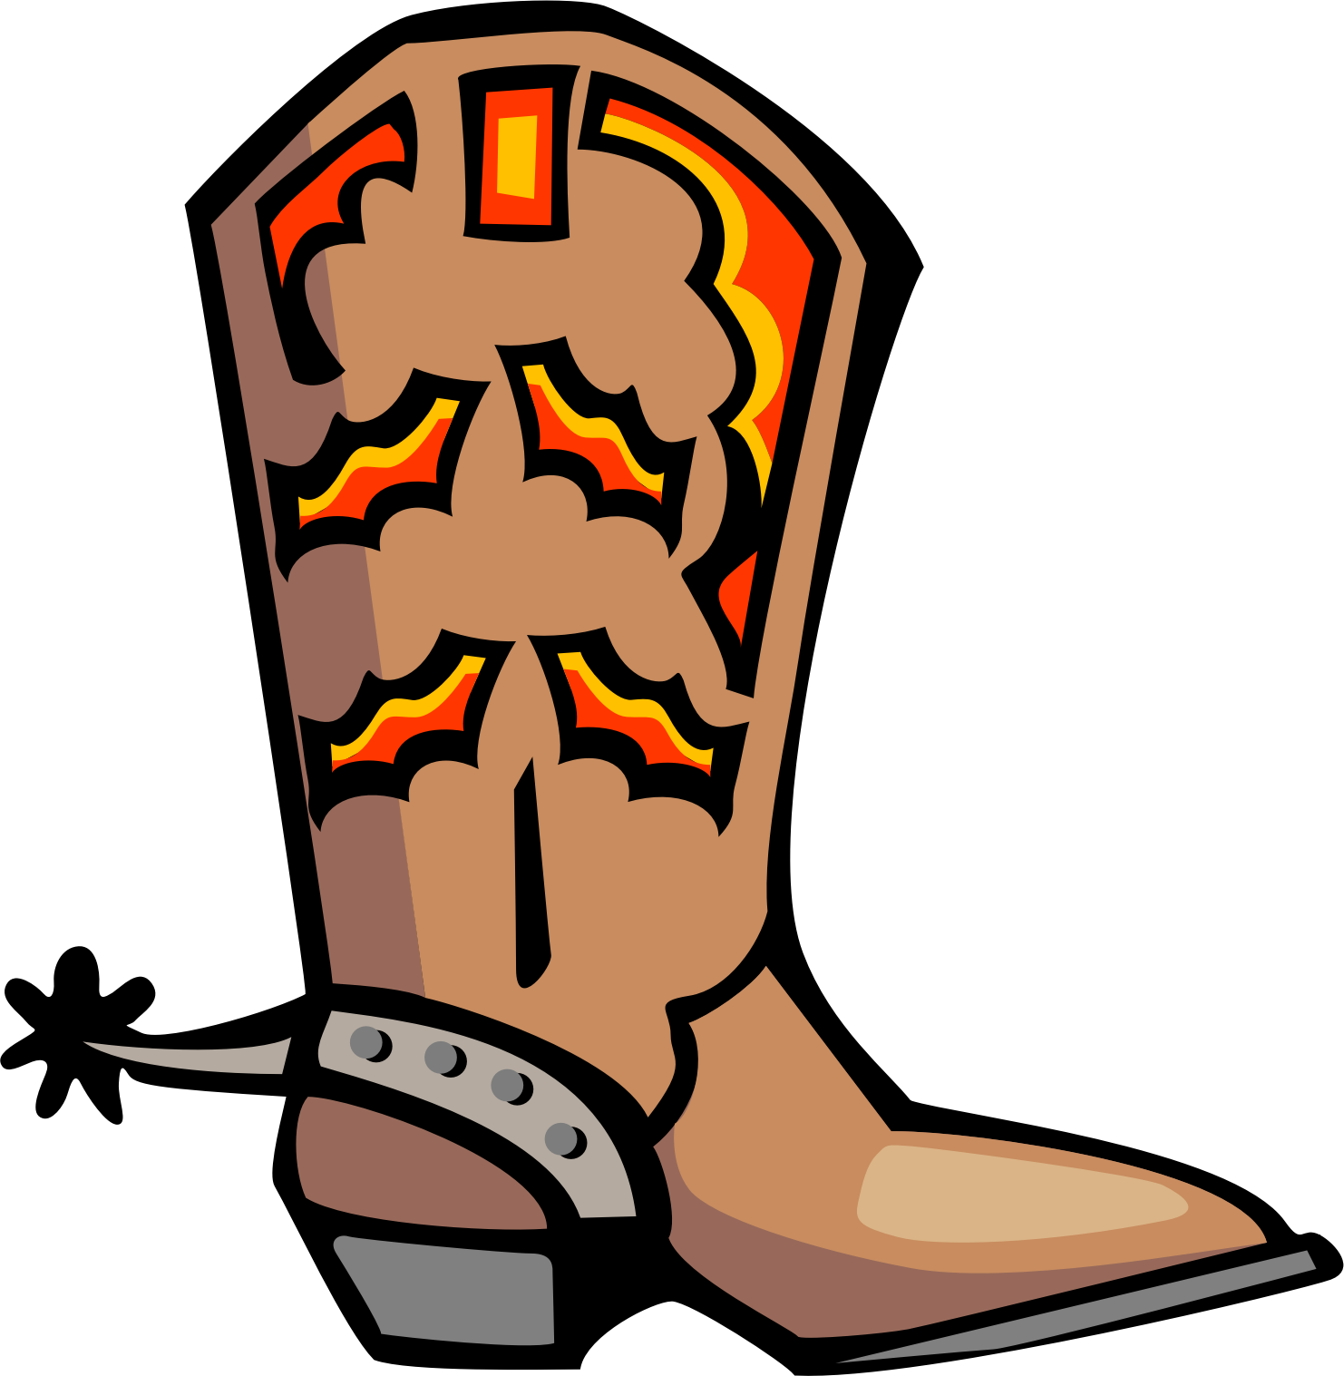

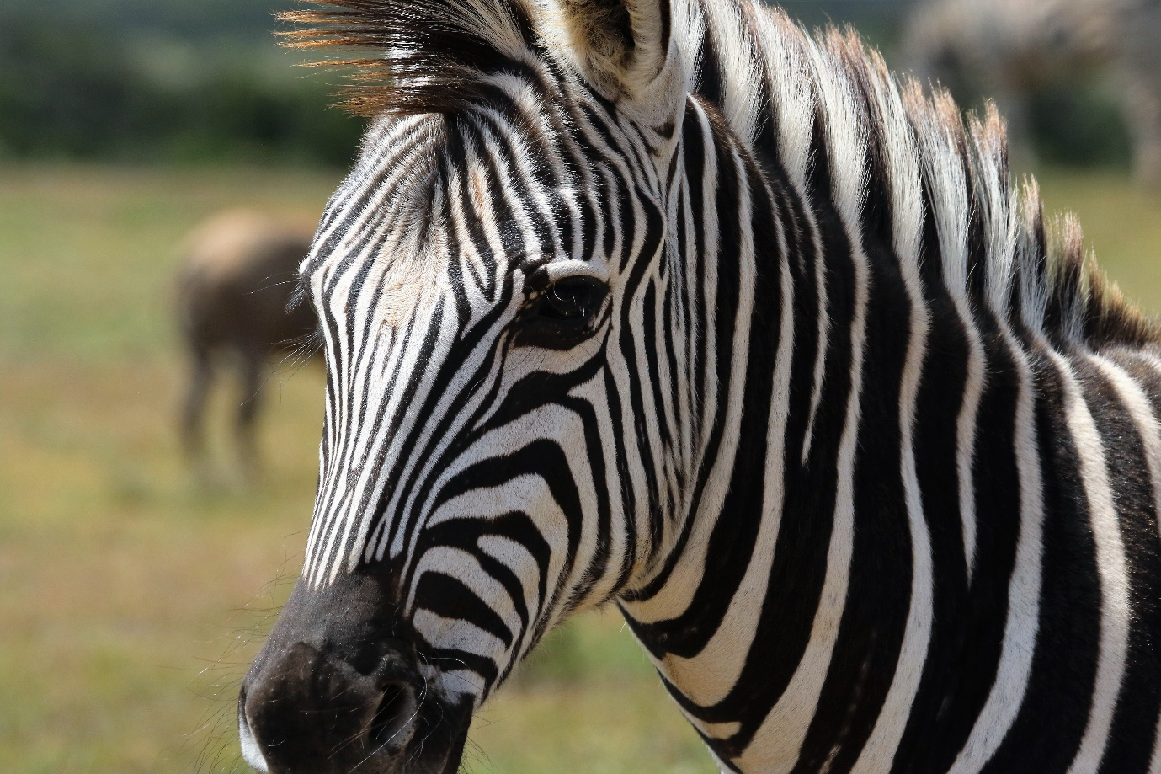

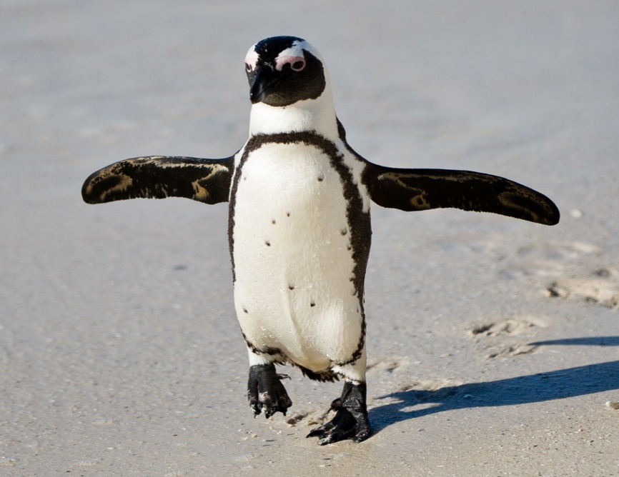
This Photo by Unknown Author is licensed under CC BY

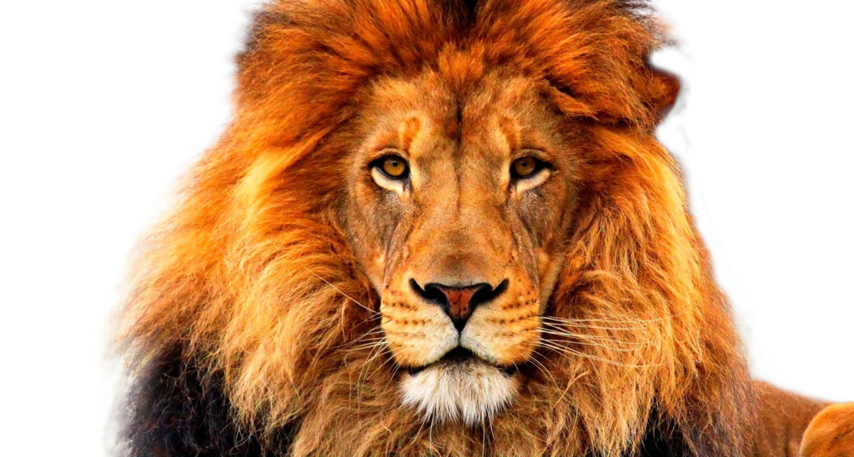

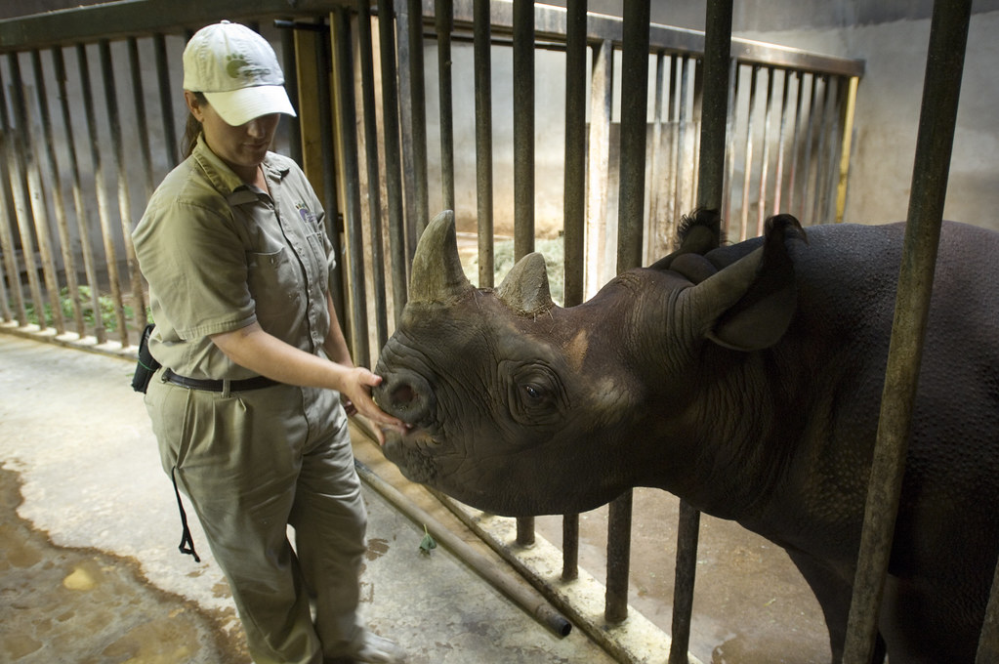
This Photo by Unknown Author is licensed under CC BY-ND

